- After May's hawkish messaging, this week's UK labour market and GDP data should ease some of the Monetary Policy Committee's worries around inflation stickiness. GDP fell in April, pay growth continued to cool, and there were further signs that conditions in the jobs market are weakening. This keeps the MPC on track to cut rates again in August and November.
- The Chancellor's spending review delivered healthy increases to the National Health Service and defence, but awarded very tough settlements elsewhere. However, like the Spring Statement, the spending review is likely to prove a stopgap rather than a durable plan. Substantial tax rises will likely be needed in the autumn Budget.
The Bank of England's Monetary Policy Committee delivered a relatively hawkish message at the May meeting, but this week's labour market and activity data should help to ease some of the committee's concerns around inflation stickiness and put the MPC on track to cut rates in August.
The labour market release reported softer pay pressures. Headline (three-month average of the annual rate) private sector regular pay growth – the BoE's preferred measure – of 5.1% in April was still well above the pace the committee considers consistent with its inflation target over the medium term. However, the outturn was down from 5.5% in the three months to March and is tracking below the BoE's projection so far in Q2. Furthermore, the three-months-on-three-months annualised rate – a better guide to recent momentum – remained soft, which should pull the headline measure lower in the coming months (Chart 1).
The data on labour market quantities offered a similarly compelling case for further policy loosening. The unemployment rate continued to tick up in April, and though ongoing data quality issues mean we place little weight on the Office for National Statistics' official estimates of unemployment, the deteriorating picture was mirrored in alternative data sources. Most notably, HMRC reported a chunky 109k fall in employees in May, which was the seventh successive monthly decline. The recent rise in labour costs and broader economic uncertainty also weighed on hiring, with job openings slipping further.
Chart 1: The momentum in private sector wage growth has cooled in the first few months of 2025
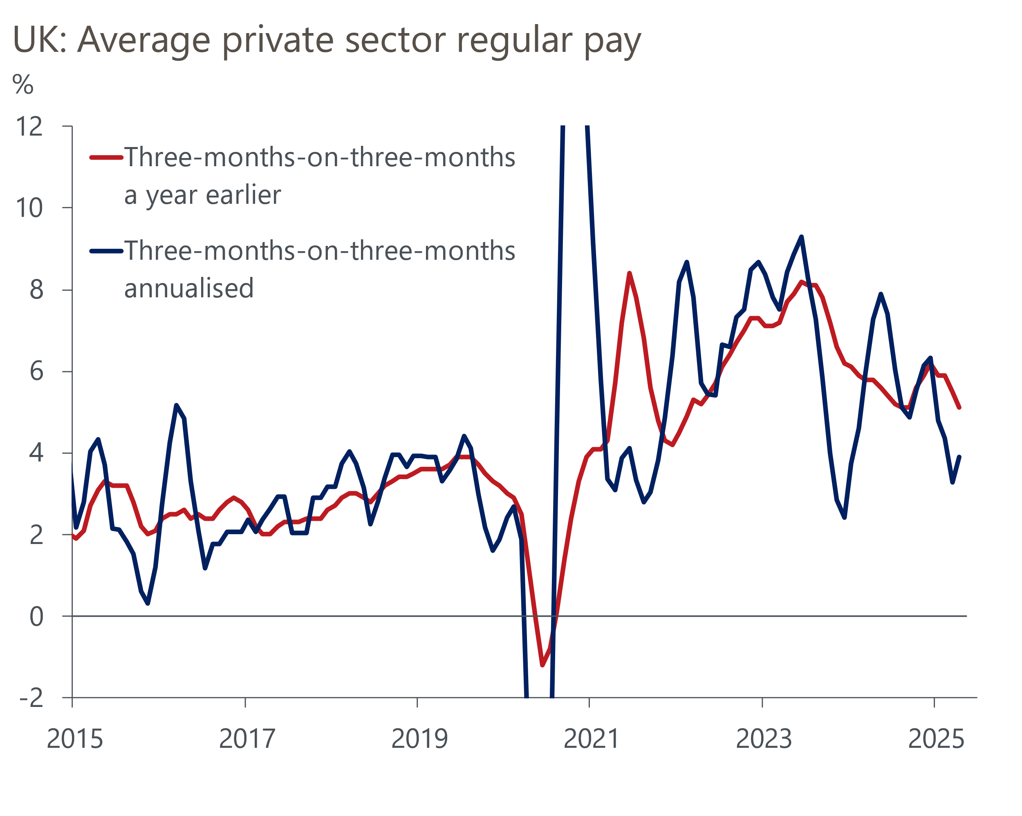
Source: Haver Analytics

April's output data also served as a reminder that the underlying momentum in the economy is much softer than the growth rates seen at the start of this year had implied. GDP fell 0.3% m/m in April, after solid rises in three of the previous four months. Digging into the detail, payback for past strength was evident in non-consumer-facing parts of the services sector, which provided the largest drag on output in April following chunky increases in the previous four months. Elsewhere, manufacturing output also fell in April, which the ONS linked to an unwinding of the temporary boost to activity from businesses attempting to get ahead of changes in US trade policy in Q1.
We continue to see evidence of residual seasonality in the GDP data with much stronger momentum in H1 of each year being followed by an abrupt slowdown from Q3. Therefore, the prospect of further payback later this year looks likely.
Taken together, the week's labour market and GDP releases suggest that the risks around the strength of pay growth and slack in the economy are probably shifting more towards the downside. Weaker demand in the jobs market should help to soothe some of the MPC's concerns that the economy is supply-constrained. BoE Governor Andrew Bailey recently said that for interest rates to continue to fall, it would be "crucial" that wage growth comes down, so further signs of waning momentum in the earnings data should give the MPC some confidence that pay growth remains on track to reach a target-consistent pace.
After some hawkish messaging at the May meeting, we think the recent data and the restrictiveness of current policy support the case for further rate cuts this year. We see the most likely scenario being that the MPC to maintains its 'cut-hold' tempo of loosening. As outlined in our preview of next week's meeting, we expect a pause at the June meeting, followed by 25bp cuts in August and November.
Switching to fiscal policy, this week also saw Chancellor Rachel Reeves present her spending review, which set out departmental day-to-day spending plans through to 2028-2029 and plans for capital spending running until 2029-2030. The spending totals were very similar to those included in the Spring Statement, so the announcement doesn't imply a change to the UK fiscal position. On average, total spending (day-to-day spending plus investment) will rise by 1.5% a year in real terms between FY2025-2026 and FY2028-2029. The two relative winners from the spending review were the National Health Service and defence, with settlements elsewhere very tight (Chart 2).
Chart 2: The average real spending rise for non-health and defence departments is just 0.4% a year
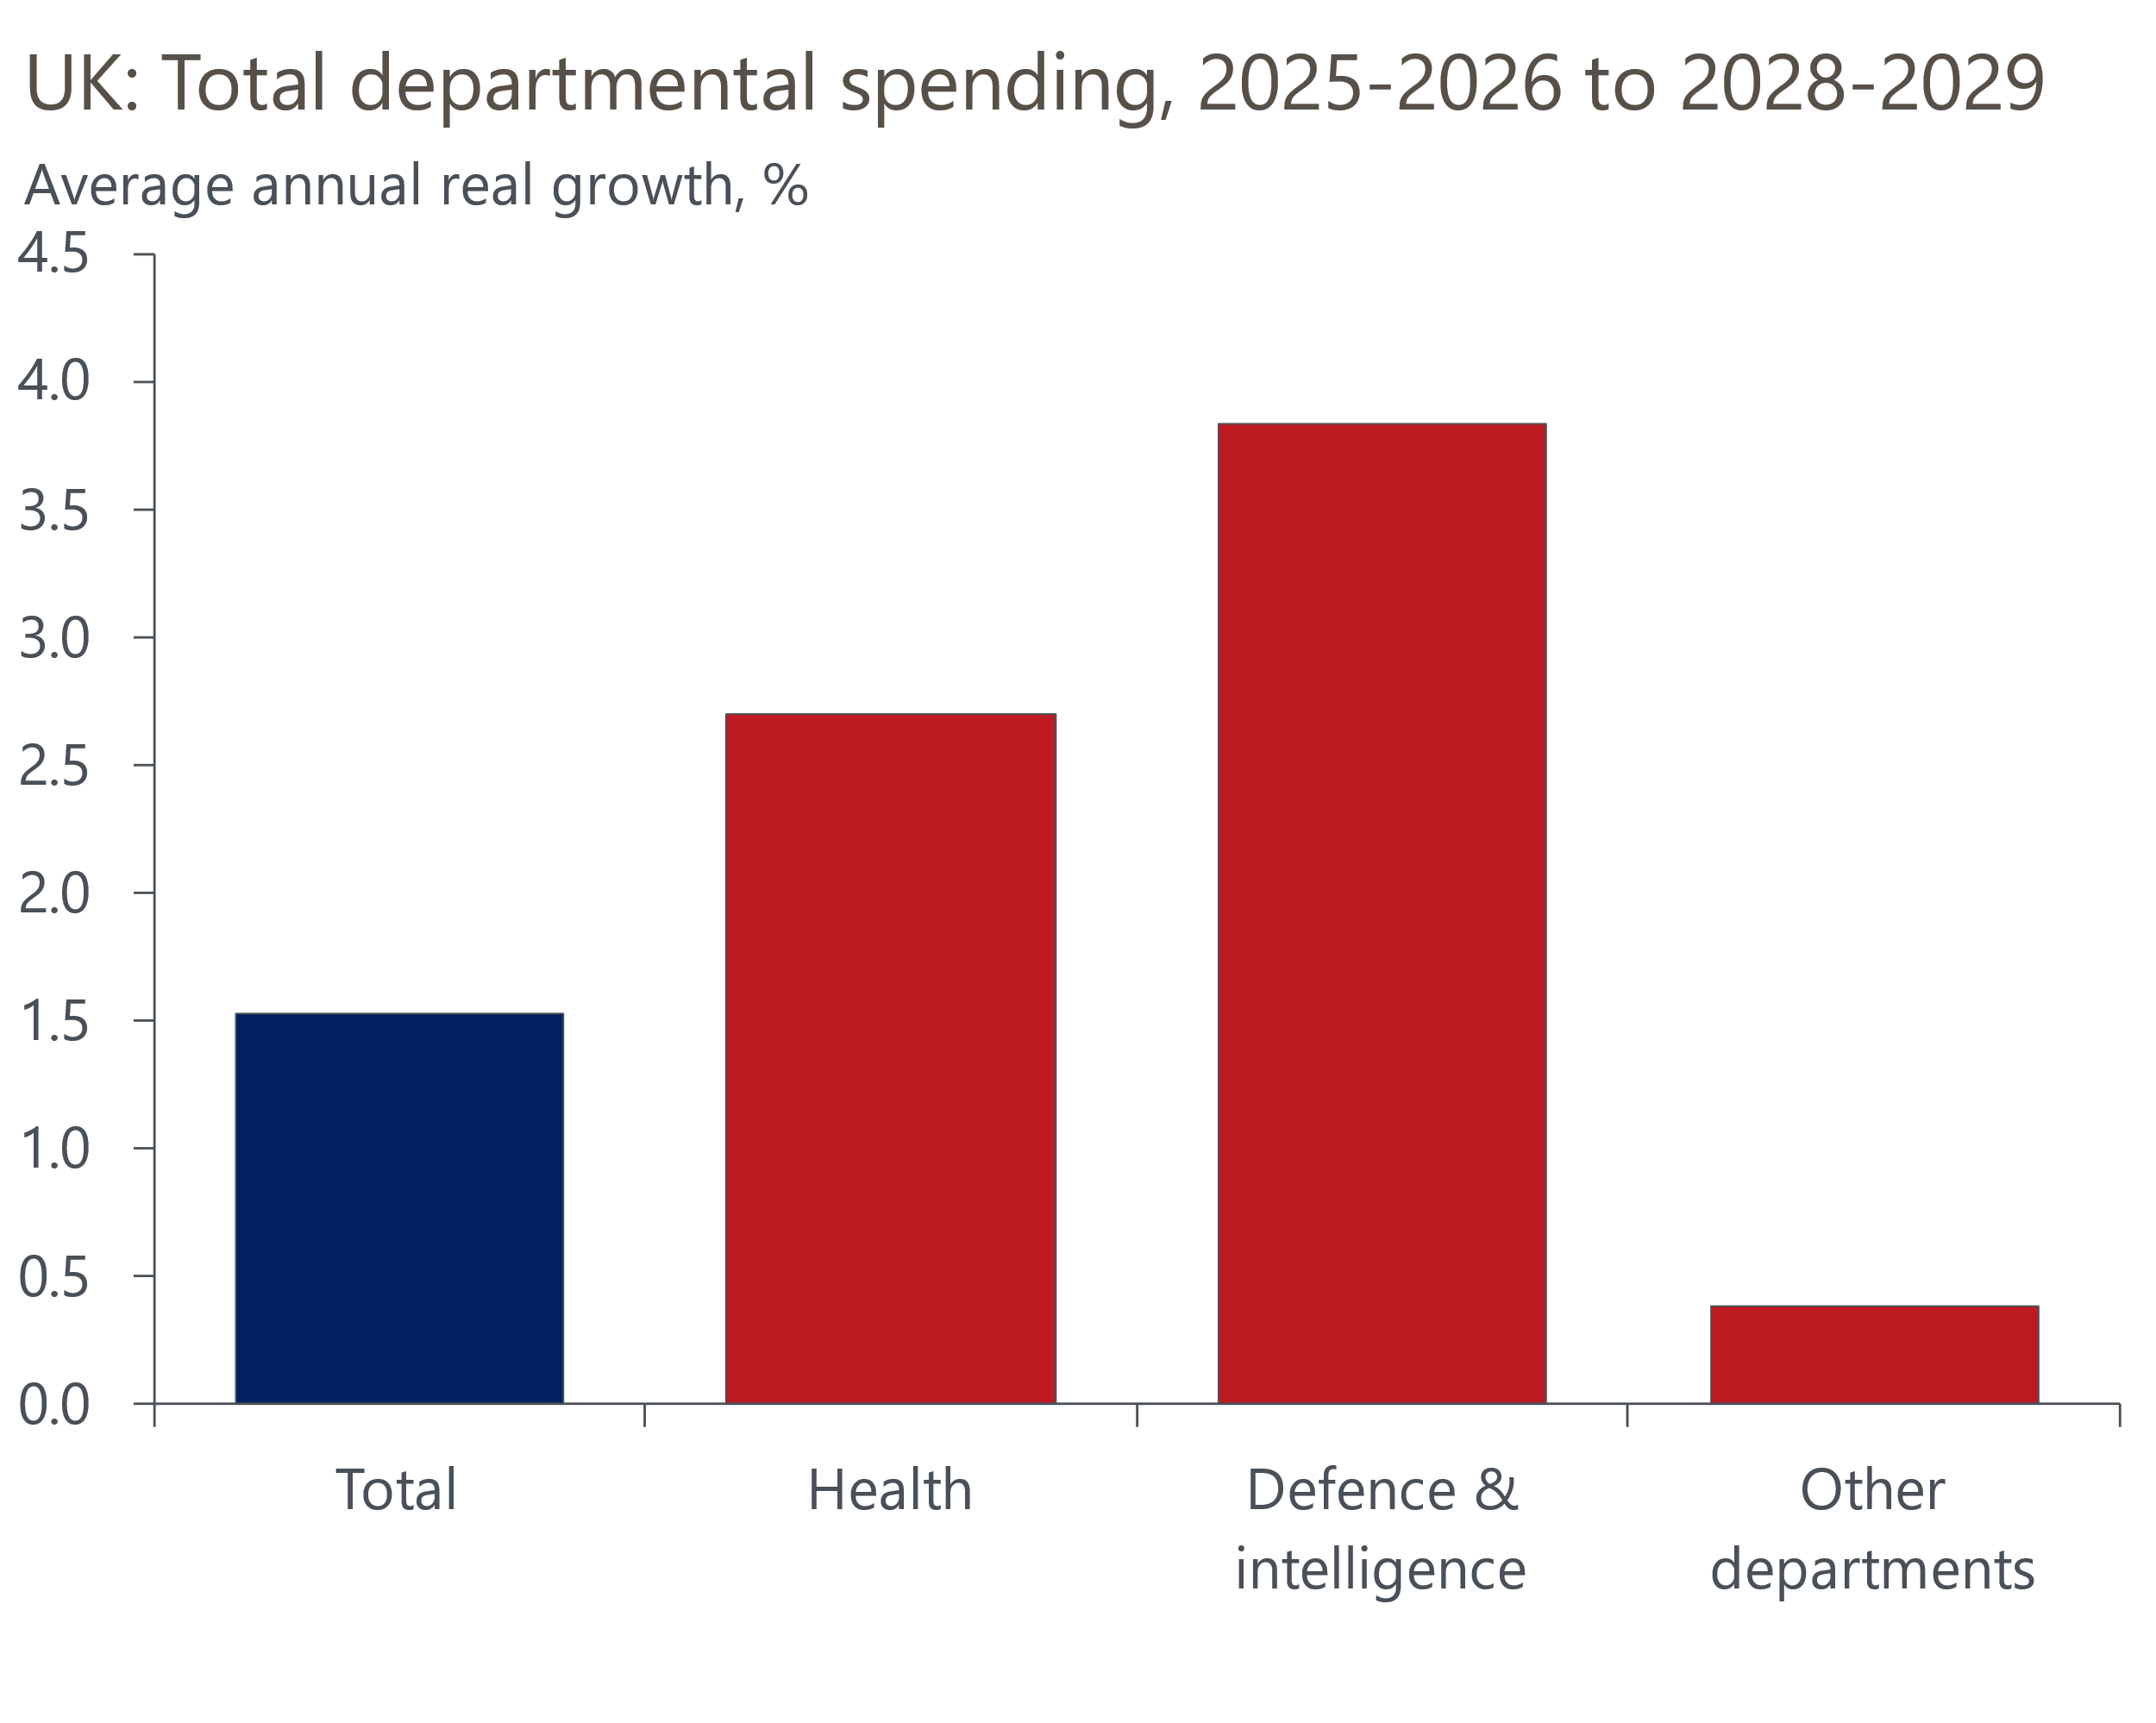
Source: Oxford Economics calculations using data from HM Treasury
Just as the Spring Statement was a stopgap, elements of the spending review are likely to face a similar fate. The new plans assume large efficiency savings that will be hard to achieve. There was no guidance on how the plans would be adjusted in the event that NATO raises its defence spending target. Furthermore, the Office for Budget Responsibility is likely to make unfavourable revisions to its borrowing projections in the autumn. Therefore, it looks increasingly likely that substantial tax increases will be needed in the autumn Budget.

The week ahead
The highlight of next week's calendar is the Bank of England's Monetary Policy Committee meeting. The MPC has settled into a cut-hold tempo for policy loosening, and May's meeting minutes and recent public comments from committee members suggest there is no real appetite among the majority to support a faster pace of cuts. Furthermore, while recent data support the case for further easing, we don’t think the data has been weak enough to prompt the committee to up the pace of cuts from the current tempo. Therefore, we expect a 7-2 vote in favour of holding Bank Rate at 4.25%, with Swati Dhingra and Alan Taylor likely to support a cut. However, the real interest will be how the MPC uses June's meeting minutes to communicate what it is focusing on ahead of the August meeting.
Data-wise, we estimate that CPI inflation fell slightly to 3.3% in May. April's surprisingly strong reading in the services category should partially unwind in May's data. This is because the outturn was artificially boosted by an unusually large increase in vehicle excise duty sub-category, which the Office for National Statistics has since revealed was due to an error in the data supplied by the Department for Transport and will be corrected in May's release. Furthermore, April's rise in services prices was also exaggerated by a very high reading in the air fares sub-category, as the month's collection dates coincided with the Easter holiday unlike in 2024. The upward pressure from this effect should also unwind in May's data. We expect minimal movements in the other major inflation categories.
Next week will also see the release of retail sales data for May. Sales volumes have risen very strongly over the first four months of the year, but we think this pace is unlikely to be sustained. In particular, there was an unusually large month-on-month jump in food sales in April which looks very likely to unwind in May's release. As a result, we forecast that total sales volumes fell 1.1% m/m in May.
Table 1: Week ahead calendar
Date | Events | Period | Measure | Unit | Previous | Forecast
Jun 18 | CPI inflation | May | m/m | % | 1.2 | 0.1
Jun 18 | CPI inflation | May | y/y | % | 3.5 | 3.3
Jun 18 | RPI inflation | May | m/m | % | 1.7 | 0.2
Jun 18 | RPI inflation | May | y/y | % | 4.5 | 4.3
Jun 18 | Land Registry house prices | Apr | y/y | % | 6.6 | 5.6
Jun 19 | BoE Bank Rate decision | Jun | Bank Rate | % | 4.25 | 4.25
Jun 20 | GfK consumer confidence | Jun | Headline | % bal | -20 | -18
Jun 20 | Retail sales inc fuel | May | m/m | % | 1.2 | -1.1
Jun 20 | Retail sales inc fuel | May | y/y | % | 5.0 | 1.0
Jun 20 | Public finances | May | PSNB ex | £bn | 20.2 | 16.5
Source: Oxford Economics

Key forecasts
Table 2: UK forecast overview
(Annual percentage changes unless specified)
 | 2023 | 2024 | 2025 | 2026 | 2027 | 2028
GDP | 0.4 | 1.1 | 1.2 | 0.9 | 1.3 | 1.8
Private consumption | 0.5 | 0.6 | 1.0 | 1.2 | 1.3 | 1.7
Fixed investment | 0.3 | 1.5 | 2.0 | 0.6 | 1.6 | 2.0
Government consumption | 1.6 | 3.0 | 1.5 | 1.7 | 1.6 | 1.7
Exports of goods and services | -0.4 | -1.2 | 0.9 | -1.3 | 1.2 | 1.5
Imports of goods and services | -1.2 | 2.7 | 1.5 | -1.0 | 1.1 | 1.4
Industrial Production | -0.8 | -1.2 | 0.0 | -0.3 | 0.7 | 1.2
Consumer prices | 7.3 | 2.5 | 3.2 | 2.5 | 2.4 | 2.1
Unemployment rate (%) | 4.1 | 4.3 | 4.6 | 4.8 | 4.8 | 4.4
Current a/c balance (% of GDP) | -3.5 | -2.7 | -2.7 | -2.7 | -2.6 | -2.6
Government balance (% of GDP) | 5.2 | 5.1 | 4.3 | 3.6 | 2.9 | 2.6
Central bank policy rate (%, EOP) | 5.25 | 4.75 | 3.75 | 3.00 | 2.50 | 2.50
10yr govt. bond yield (%, EOP) | 3.54 | 4.57 | 4.50 | 3.96 | 3.46 | 3.35
Exchange rate (US$ per £, EOP) | 1.27 | 1.25 | 1.35 | 1.35 | 1.35 | 1.35
Exchange rate (euro per £, EOP) | 1.15 | 1.21 | 1.19 | 1.19 | 1.19 | 1.19
Source: Oxford Economics
Table 3: Quarterly forecasts for the UK
 | 2025 |  |  |  | 2026
 | Q1 | Q2 | Q3 | Q4 | Q1 | Q2 | Q3 | Q4
GDP (% year) | 1.3 | 1.0 | 1.1 | 1.2 | 0.7 | 0.8 | 0.9 | 1.0
CPI inflation (% year) | 2.8 | 3.4 | 3.5 | 3.2 | 3.0 | 2.2 | 2.4 | 2.5
Bank Rate (%, EOP) | 4.50 | 4.25 | 4.00 | 3.75 | 3.50 | 3.25 | 3.25 | 3.00
10yr gilt yield (%, EOP) | 4.70 | 4.70 | 4.61 | 4.50 | 4.37 | 4.25 | 4.11 | 3.96
US$ per £ (EOP) | 1.29 | 1.35 | 1.35 | 1.35 | 1.35 | 1.35 | 1.35 | 1.35
Euro per £ (EOP) | 1.20 | 1.19 | 1.19 | 1.19 | 1.19 | 1.19 | 1.19 | 1.19
Source: Oxford Economics

Latest Country Economic Forecast:
May 20, 2025

Recent publications

Data Insights
GDP fell in April, as Q1's strength partially unwound
Labour market data suggests disinflation is on track
Q2 GDP growth expected to outperform the PMIs
March's surge in mortgage lending unwound in April's data
Challenges for the manufacturing sector remain

Research Briefings
MPC Preview – Divided committee to pause in June
Unconvincing spending review is another fiscal stopgap
Tough fiscal choices looming in the Autumn
What the EU deal means for trade and growth
Employment nowcast suggests limited impact from NICs rise

Contacts

Oxford Economics' UK team
- Andrew Goodwin - Chief UK Economist - agoodwin@oxfordeconomics.com
- Edward Allenby - UK Economist - eallenby@oxfordeconomics.com

